**Delphi Test Project**

**About the Source Code:** There are mainly 3 pas files and they are:

* uMain.pas: This is mainly the User Interface. Is has all the functionality related to yser interaction.
* uClassDef.pas: This unit contains all the necessary classes like Trange, TRangeList, TRangeElement, TRangeElementList.
* uDM.pas: This unit contains all database related functionalities like Load from Database, Save to Database.

**Running/Compiling the code:**

Keep all the files under one folder say “DelphiCodingTest”.

There is a INI file same as the Project name “DelphiCodingTest.ini”. Please provide the Database connetion string in this file.

The content of the INI file looks like below:

[SETUP]

ConnectionString=**Provider=SQLOLEDB.1;Integrated Security=SSPI;Persist Security Info=False;Initial Catalog=PraTik;Data Source=.;**

Please modify the secion in Bold.

Open the Source Code using Delphi 7 and build the same.

**About the Main Screen:** The main screen of this project has the following buttons:

* Loda Data Into Memeory: On click of this button default data menyioned in your requirement document will get loaded into memory.
* Clean Database Tables: This action will Truncate all the database tables like Range, RangeElement, RangeSubElement.
* Save Data Into Database: This action will save the information from memory into Database.
* Display Total Planned Quantity – Range: This action will display the total quentity of Range Id 1.
* Display Total Planned Quantity – Range Element: This action will display the total quantity of each and every Element. If a Element has Sub Element make sure you have entered Quantity=0 for the element as only the Sub Element only should have the Qudntity filled.
* Display Data In Treeview: This action will display the data in Tree View.

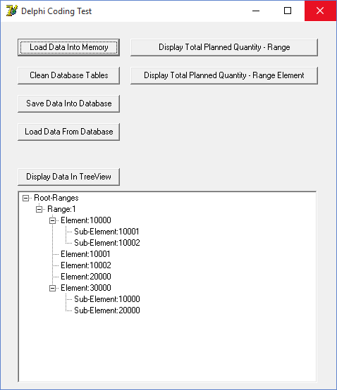

Fig1: Main Screen